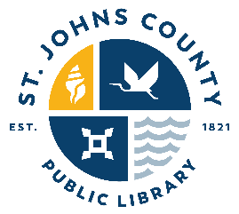 | ST. JOHNS COUNTY  PUBLIC LIBRARY SYSTEM  6670 US 1 South  St. Augustine, Florida 32086
LIABILITY WAIVER RELEASE FOR PARTICIPATION IN ST. JOHNS COUNTY PUBLIC LIBRARY SYSTEM FOOD PROGRAM

By signing this sheet, you hereby acknowledge that attendance at or participation in The Life of a Storygirl on October 2, 2025, by you, including the consumption of food prepared during the program, could cause injury to you. By signing this form, you also acknowledge that food or beverages served at The Life of a Storygirl may contain any or all of the following ingredients: milk, eggs, peanuts, tree nuts (including almonds, cashews, or walnuts), fish, shellfish, soy, and wheat. As material consideration for St. Johns County to allow you to attend the event, you agree to assume any and all liabilities or losses which may result from or arise out of attendance at or participation in The Life of a Storygirl at Bartram Trail Branch Library.

BY SIGNING THIS SHEET, YOU ACKNOWLEDGE THAT YOU HAVE CAREFULLY READ
AND FULLY UNDERSTAND THIS RELEASE OF LIABILITY.
 | Name | Signature
1
2
3
4
5
6
7
8
9
10
11
12
13
14
15
16
17
18
19
20
21
22
23
24
25
26
27
28
29
30
31
32
33
34
35
36
37
38
39
40
41
42
43
44
45
46
47
48
49
50
51
52
53
54
55
56
57
58
59

